
Project Operating System Theory The evolution of operating system with mini OS : HmadSO

Department : Math Informatique

Major : Génie du logiciel et Système informatiques distribués

Subject : Operating System theory
Realized By :

AIT EL CIAD HMAD
Under direction :

Mr Azougagh Driss

Contents
Introduction 4
Before operating system 5
What is operating system 9
First operating system 10
List of operating system 11
List of operating system 11
Services provide by Operating system 14
Program execution 14

- Introduction

Computer operating systems provide a set of functions needed and used by most application programs on a computer, and the links needed to control and synchronize computer hardware. On the first computers, with no operating system, every program needed the full hardware specification to run correctly and perform standard tasks, and its own drivers for peripheral devices like printers and punched paper card readers. The growing complexity of hardware and application programs eventually made operating systems a necessity for everyday use.

An operating system acts as an intermediary between the user of a computer and the computer hardware. The purpose of an operating system is to provide an environment in which a user can execute programs in a convenient and efficient manner.
An operating system is software that manages the computer hard- ware. The hardware must provide appropriate mechanisms to ensure the correct operation of the computer system and to prevent user programs from interfering with the proper operation of the system.

Internally, operating systems vary greatly in their makeup, since they are organized along many different lines. The design of a new operating system is a major task. It is important that the goals of the system be well defined before the design begins. These goals form the basis for choices among various algorithms and strategies.
Because an operating system is large and complex, it must be created piece by piece. Each of these pieces should be a well-delineated portion of the system, with carefully defined inputs, outputs, and functions.

So in this report I am going to present before operating system what is an operating system, First operating system also some example of operating systems and in the end I am going to present my own operating system which called HmadOS.

- Before operating system

Early computers ran one program at a time. Programs were directly loaded from (for example) paper tape with holes punched in it.
You'd program the earliest computers by setting a large set of on-off switches.
Colossus was a set of computers developed by British codebreakers in 1943–1945 to help in the cryptanalysis of the Lorenz cipher. Colossus used thermionic valves (vacuum tubes) to perform Boolean and counting operations. Colossus is thus regarded as the world's first programmable, electronic, digital computer, although it was programmed by switches and plugs and not by a stored program.

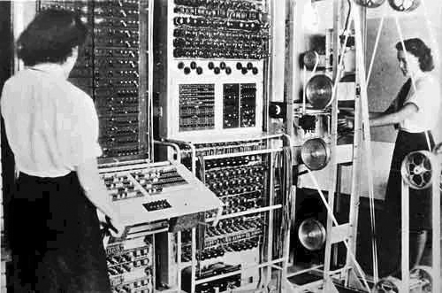

The Atlas Computer was a joint development between the University of Manchester, Ferranti, and Plessey. The first Atlas, installed at Manchester University and officially commissioned in 1962, was one of the world's first supercomputers, considered to be the most powerful computer in the world at that time.[1] It was said that whenever Atlas went offline half of the United Kingdom's computer capacity was lost.[2] It was a second-generation machine, using discrete germanium transistors. Two other Atlas machines were built: one for British Petroleum and the University of London, and one for the Atlas Computer Laboratory at Chilton near Oxford.
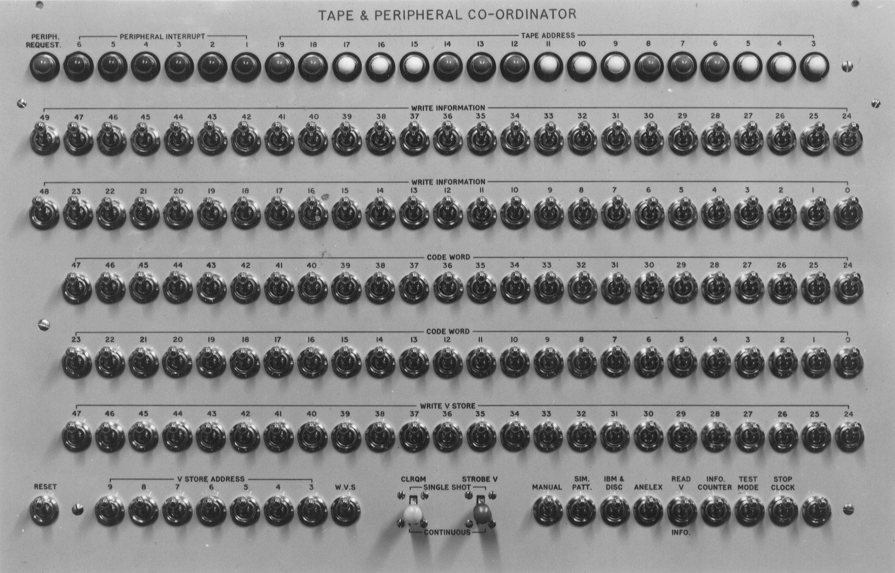

A derivative system was built by Ferranti for Cambridge University. Called the Titan, or Atlas 2, it had a different memory
organisation and ran a time-sharing operating system developed by Cambridge University Computer Laboratory. Two further Atlas 2s were delivered: one to the CAD Centre in Cambridge (later called CADCentre, then AVEVA), and the other to the Atomic Weapons Research Establishment (AWRE), Aldermaston.
The University of Manchester's Atlas was decommissioned in 1971,[3] but the last was in service until 1974.[4] Parts of the Chilton Atlas are preserved by National Museums Scotland in Edinburgh; the main console itself was rediscovered in July 2014 and is at Rutherford Appleton Laboratory in Chilton, near Oxford. CADCentre's Atlas 2 was decommissioned in late 1976.

The Manchester Mark 1 was one of the earliest stored-program computers, developed at the Victoria University of Manchester from the Small-Scale Experimental Machine (operational in June 1948). It was also called the Manchester Automatic Digital Machine, or MADM. Work began in August 1948, and the first version was operational by April 1949.
The program written to search for Mersenne primes ran error-free for nine hours on the night of 16/17 June 1949.

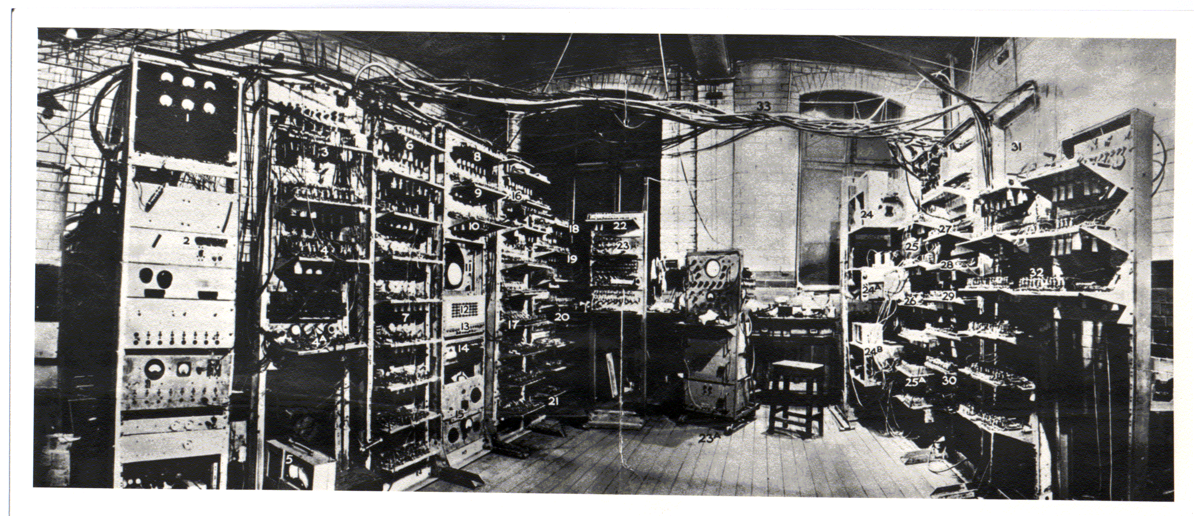

the word "Computer" is used to mean the sort of device that exists nowadays in the billions. Of this vast number of computers, all but an insignificantly tiny number are digital electronic programmable computers with stored programs. I'm sure the original question is not about how people with the job title "Computer" spent their working day. In between those two types of computer, there is a progression of interesting devices not covered in this answer.

- What is operating system

An operating system (OS) is the program that, after being initially loaded into the computer by a boot program, manages all the other programs in a computer. The other programs are called applications or application programs. The application programs make use of the operating system by making requests for services through a defined application program interface (API). In addition, users can interact directly with the operating system through a user interface such as a command line or a graphical user interface (GUI).

An operating system performs these services for applications:

- In a multitasking operating system where multiple programs can be running at the same time, the operating system determines which applications should run in what order and how much time should be allowed for each application before giving another application a turn.
- It manages the sharing of internal memory among multiple applications.
- It handles input and output to and from attached hardware devices, such as hard disks, printers, and dial-up ports.
- It sends messages to each application or interactive user (or to a system operator) about the status of operation and any errors that may have occurred.
- It can offload the management of what are called batch jobs (for example, printing) so that the initiating application is freed from this work.
- On computers that can provide parallel processing, an operating system can manage how to divide the program so that it runs on more than one processor at a time.

All major computer platforms (hardware and software) require and sometimes include an operating system, and operating systems must be developed with different features to meet the specific needs of various form factors.

- First operating system

The first operating system used for real work was GM-NAA I/O, produced in 1956 by General Motors' Research division for its IBM 704. Most other early operating systems for IBM mainframes were also produced by customers.

The main function of GM-NAA I/O was to automatically execute a new program once the one that was being executed had finished (batch processing). It was formed of shared routines to the programs that provided common access to the input/output devices. Some version of the system was used in about forty 704 installations.

Early operating systems were very diverse, with each vendor or customer producing one or more operating systems specific to their particular mainframe computer. Every operating system, even from the same vendor, could have radically different models of commands, operating procedures, and such facilities as debugging aids. Typically, each time the manufacturer brought out a new machine, there would be a new operating system, and most applications would have to be manually adjusted, recompiled, and retested.

- List of operating system

Operating system | Date first released | Platform | Developer
AIX and AIXL | Unix and Linux history. | Various | IBM
AmigaOS | Currently no AmigaOS history. | Amiga | Commodore
Android | November 5, 2007 | Mobile | Google
BSD | Unix and Linux history. | Various | BSD
Caldera Linux | Unix and Linux history. | Various | SCO
Corel Linux | Unix and Linux history. | Various | Corel
CP/M | Currently no CP/M history. | IBM | CP/M
Debian Linux | Unix and Linux history. | Various | GNU
DUnix | Unix and Linux history. | Various | Digital
DYNIX/ptx | Unix and Linux history. | Various | IBM
HP-UX | Unix and Linux history. | Various | Hewlett Packard
iOS | 2010 | Mobile | Apple
IRIX | Unix and Linux history. | Various | SGI
Kondara Linux | Unix and Linux history. | Various | Kondara
Linux | Unix and Linux history. | Various | Linus Torvalds
MAC OS 8 | Apple operating system history. | Apple Macintosh | Apple
MAC OS 9 | Apple operating system history. | Apple Macintosh | Apple
MAC OS 10 | Apple operating system history. | Apple Macintosh | Apple
MAC OS X | Apple operating system history. | Apple Macintosh | Apple
Mandrake Linux | Unix and Linux history. | Various | Mandrake
MINIX | Unix and Linux history. | Various | MINIX
MS-DOS 1.x | MS-DOS history. | IBM | Microsoft
MS-DOS 2.x | MS-DOS history. | IBM | Microsoft
MS-DOS 3.x | MS-DOS history. | IBM | Microsoft
MS-DOS 4.x | MS-DOS history. | IBM | Microsoft
MS-DOS 5.x | MS-DOS history. | IBM | Microsoft
MS-DOS 6.x | MS-DOS history. | IBM | Microsoft
NEXT-STEP | Apple operating system history. | Various | Apple
OS/2 | 1987 | IBM | IBM
OSF/1 | Unix and Linux history. | Various | OSF
QNX | Unix and Linux history. | Various | QNX
Red Hat Linux | Unix and Linux history. | Various | Red Hat
SCO | Unix and Linux history. | Various | SCO
Slackware Linux | Unix and Linux history. | Various | Slackware
Sun Solaris | Unix and Linux history. | Various | Sun
SuSE Linux | Unix and Linux history. | Various | SuSE
Symbian | 1997 | Mobile | Nokia
System 1 | Apple operating system history. | Apple Macintosh | Apple
System 2 | Apple operating system history. | Apple Macintosh | Apple
System 3 | Apple operating system history. | Apple Macintosh | Apple
System 4 | Apple operating system history. | Apple Macintosh | Apple
System 6 | Apple operating system history. | Apple Macintosh | Apple
System 7 | Apple operating system history. | Apple Macintosh | Apple
System V | Unix and Linux history. | Various | System V
Tru64 Unix | Unix and Linux history. | Various | Digital
Turbolinux | Unix and Linux history. | Various | Turbolinux
Ultrix | Unix and Linux history. | Various | Ultrix
Unisys | Unix and Linux history. | Various | Unisys
Unix | Unix and Linux history. | Various | Bell labs
UnixWare | Unix and Linux history. | Various | UnixWare
VectorLinux | Unix and Linux history. | Various | VectorLinux
Windows 2000 | Microsoft Windows history. | IBM | Microsoft
Windows 2003 | Microsoft Windows history. | IBM | Microsoft
Windows 3.X | Microsoft Windows history. | IBM | Microsoft
Windows 7 | Microsoft Windows history. | IBM | Microsoft
Windows 8 | Microsoft Windows history. | IBM | Microsoft
Windows 95 | Microsoft Windows history. | IBM | Microsoft
Windows 98 | Microsoft Windows history. | IBM | Microsoft
Windows 10 | Microsoft Windows history. | IBM | Microsoft
Windows CE | Microsoft Windows history. | PDA | Microsoft
Windows ME | Microsoft Windows history. | IBM | Microsoft
Windows NT | Microsoft Windows history. | IBM | Microsoft
Windows Vista | Microsoft Windows history. | IBM | Microsoft
Windows XP | Microsoft Windows history. | IBM | Microsoft
Xenix | Unix and Linux history. | Various | Microsoft

- Services provide by Operating system

An Operating System provides services to both the users and to the programs.
It provides programs an environment to execute.
It provides users the services to execute the programs in a convenient manner.
Following are a few common services provided by an operating system :
- Program execution
- I/O operations
- File System manipulation
- Communication
- Error Detection
- Resource Allocation
- Protection

- Program execution

Operating systems handle many kinds of activities from user programs to system programs like printer spooler, name servers, file server, etc. Each of these activities is encapsulated as a process.
A process includes the complete execution context (code to execute, data to manipulate, registers, OS resources in use). Following are the major activities of an operating system with respect to program management :

- Loads a program into memory.
- Executes the program.
- Handles program's execution.
- Provides a mechanism for process synchronization.
- Provides a mechanism for process communication.
- Provides a mechanism for deadlock handling.

2) I/O Operation

An I/O subsystem comprises of I/O devices and their corresponding driver software. Drivers hide the peculiarities of specific hardware devices from the users.

An Operating System manages the communication between user and device drivers.

- I/O operation means read or write operation with any file or any specific I/O device.
- Operating system provides the access to the required I/O device when required.

3) File system manipulation

A file represents a collection of related information. Computers can store files on the disk (secondary storage), for long-term storage purpose. Examples of storage media include magnetic tape, magnetic disk and optical disk drives like CD, DVD. Each of these media has its own properties like speed, capacity, data transfer rate and data access methods.

A file system is normally organized into directories for easy navigation and usage. These directories may contain files and other directions. Following are the major activities of an operating system with respect to file management :

- Program needs to read a file or write a file.
- The operating system gives the permission to the program for operation on file.
- Permission varies from read-only, read-write, denied and so on.
- Operating System provides an interface to the user to create/delete files.
- Operating System provides an interface to the user to create/delete directories.
- Operating System provides an interface to create the backup of file system.

4) Communication

In case of distributed systems which are a collection of processors that do not share memory, peripheral devices, or a clock, the operating system manages communications between all the processes. Multiple processes communicate with one another through communication lines in the network.

The OS handles routing and connection strategies, and the problems of contention and security. Following are the major activities of an operating system with respect to communication :

- Two processes often require data to be transferred between them Both the processes can be on one computer or on different computers, but are connected through a computer network.

- Communication may be implemented by two methods, either by Shared Memory or by Message Passing.

5) Error handling

Errors can occur anytime and anywhere. An error may occur in CPU, in I/O devices or in the memory hardware. Following are the major activities of an operating system with respect to error handling −

The OS constantly checks for possible errors.
The OS takes an appropriate action to ensure correct and consistent computing.

6) Resource Management

In case of multi-user or multi-tasking environment, resources such as main memory, CPU cycles and files storage are to be allocated to each user or job. Following are the major activities of an operating system with respect to resource management

- The OS manages all kinds of resources using schedulers.
- CPU scheduling algorithms are used for better utilization of CPU.

7) Protection

Considering a computer system having multiple users and concurrent execution of multiple processes, the various processes must be protected from each other's activities.

Protection refers to a mechanism or a way to control the access of programs, processes, or users to the resources defined by a computer system. Following are the major activities of an operating system with respect to protection −

- The OS ensures that all access to system resources is controlled.
- The OS ensures that external I/O devices are protected from invalid access attempts.
- The OS provides authentication features for each user by means of passwords.

Functions of Operating System

There are Many Functions those are Performed by the Operating System But the Main Goal of Operating System is to Provide the Interface between the user and the hardware Means Provides the Interface for Working on the System by the user. The various Functions those are Performed by the Operating System are as Explained below:-

Operating System as a Resource Manager

Operating System Also Known as the Resource Manager Means Operating System will Manages all the Resources those are Attached to the System means all the Resource like Memory and Processor and all the Input output Devices those are Attached to the System are Known as the Resources of the Computer System and the Operating system will Manage all the Resources of the System. The Operating System will identify at which Time the CPU will perform which Operation and in which Time the Memory is used by which Programs. And which Input Device will respond to which Request of the user means When the Input and Output Devices are used by the which Programs. So this will manage all the Resources those are attached to the Computer System.
Storage Management

Operating System also Controls the all the Storage Operations means how the data or files will be Stored into the computers and how the Files will be Accessed by the users etc. All the Operations those are Responsible for Storing and Accessing the Files is determined by the Operating System Operating System also Allows us Creation of Files, Creation of Directories and Reading and Writing the data of Files and Directories and also Copy the contents of the Files and the Directories from One Place to Another Place.

1) Process Management :

The Operating System also Treats the Process Management means all the Processes those are given by the user or the Process those are System ‘s own Process are Handled by the Operating System . The Operating System will Create the Priorities foe the user and also Start or Stops the Execution of the Process and Also Makes the Child Process after dividing the Large Processes into the Small Processes.

2) Memory Management:
Operating System also Manages the Memory of the Computer System means Provide the Memory to the Process and Also Deallocate the Memory from the Process. And also defines that if a Process gets completed then this will deallocate the Memory from the Processes.

3) Extended Machine :
Operating System also behaves like an Extended Machine means Operating system also Provides us Sharing of Files between Multiple Users, also Provides Some Graphical Environments and also Provides Various Languages for Communications and also Provides Many Complex Operations like using Many Hardware’s and Software’s.

4) Mastermind:
Operating System also performs Many Functions and for those Reasons we can say that Operating System is a Mastermind. It provides Booting without an Operating System and Provides Facility to increase the Logical Memory of the Computer System by using the Physical Memory of the Computer System and also provides various Types of Formats Like NTFS and FAT File Systems.

Operating System also controls the Errors those have been Occurred into the Program and Also Provides Recovery of the System when the System gets Damaged Means When due to Some Hardware Failure , if System Doesn’t Works properly then this Recover the System and also Correct the System and also Provides us the Backup Facility. And Operating System also breaks the large program into the Smaller Programs those are also called as the threads. And execute those threads one by one.

- What are the steps to create your own operating system.
Programming OS is one of the most interesting and satisfying experience in terms of learning.

What you need :

- Get yourself familiar with qemu (x86 emulator), gdb (debugging), ctags (Navigating code), git (maintaining repo).

- sufficient knowledge of C, ASM, x-86 architecture, calling convention for x86

Firstly, I think you should really ask yourself what level of complexity you wish to have in your OS. Sketch out the rough design, components you wish to program etc.

If learning OS concepts is your main aim, I would suggest start with an existing implementation.
something like MIT - JOS. 6.828 / Fall 2011 / Overview
It will provide you with skeleton code for memory management, page table setup stuff and then you would incrementally add support of various syscalls, interrupt handlers etc.

start a operating system from the beginning

Step 1: Writing your own boot loader: Use BOCHS which is a 32bit emulator. Read some theory about where BIOS is loaded, real modes, protected mode and then start implementing. This link might help you : Category: Babystep - OSDev Wiki

Step 2: Write code for defining your kernel entry point where before calling main, you will setup your stack, GDT tables etc.

Step 3: Now you have task of writing ISR (interrupt service routines). Start from basic stuff. Set up your own GDT, IDT tables. Write your own printf by writing to video memory at 0xB8000. Refer this Printing To Screen.

Step 4: Writing code for PIC (programmable interrupt microcontroller). PIC tells processor what IRQ to call within our IDT (interrupt descriptor table) when interrupt is recieved from device. Refer this : Operating Systems Development Series. PIT (programmable interrupt timer) is your system clock. Code up a simple timer handler.

Step 5: Have a basic device driver for your keyboard by mapping its scan codes. Write this into your keyboard interrupt handler.

Step 6: Now comes part of handling physical memory. Your BIOS e801 map will give you total main memory available. Further when you will come down to paging, it is going to request you physical pages of size 4 Kb. Divide memory into page size and have a bit-map/free list type physical memory manager which will keep track of occupied and free pages.

Step 7: Now arrives the mammoth task of programming virtual page tables. Start by reading first some theory that you won't usually find in OS books like one's which explain when to load cr3 register with physical addr of pml4 in case of 64-bit to enable paging, self referencing page tables etc. Map your kernel to higher memory address.

Write code for heap memory management, kernel malloc etc.

Step 8: Now comes part of process management. Define simple data structres for your managing your processes - PCB, MM_struct, task_struct (required later on) etc. (refer linux 1.0). Now write procedure for loading simple kernel level process. Once you have this running, go on do define ring permissions and then user level processes.

Write a basic round robin scheduler by keeping simple runqueue.

Step 9: Once you have processes running, now you have job of loading processes from memory. Define very naive kind of in memory file system, then procedure for reading elf binary and loading it in your memory.

Step 10: If you want to proceed more, you have task of writing your own file system and later on you can go on to add support for network stack, multi threading etc.

- what is HmadOS

HmadOS is a simple operating system created by AIT EL CAID Hmad engineering student in Computer Science in “ L’Ecole Normale Supérieure de l’Enseignement Technique de Mohammedia (ENSET Mohammedia) “
the simple operating system is Inspired from Gnu / Linux operating system .
So in this report I will explain how I made this mini operating system

1) structure of project

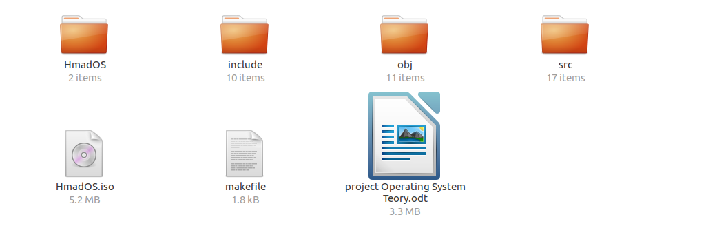

there is 5 folder :
Hma dOS :folder conatin

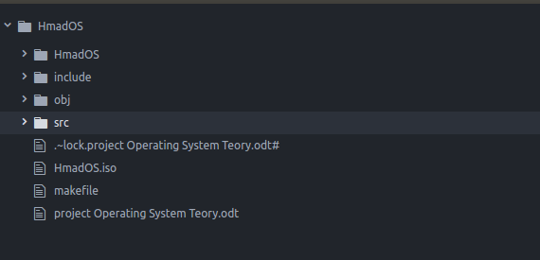

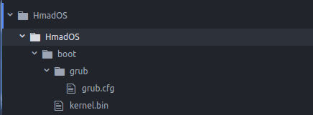

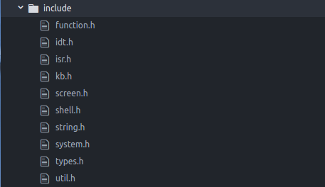

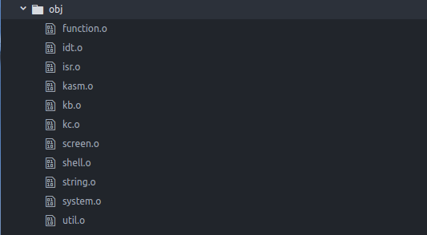

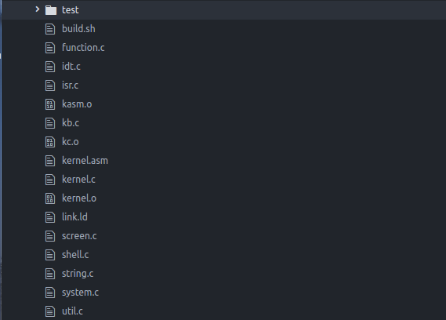

Conclusion

The application software and the system software form the basis of a user friendly computer. Both softwares are inter-related and enhance computer functionality. Therefore, it is not surprising when some system softwares come with pre-installed application softwares like web browsers Internet explorer) and antivirus (Microsoft antivirus, etc.). Both the application software and the system software are inter-related as one forms a platform for the other.

Therefore, since the computer has now become part of human existence as day to day activities are performed on a computer (which could be a mobile phone, laptops/notebooks/desktop computers, smart watch, and all machines programmed and designed to perform some functions), there is need for more application to be developed and the operating system softwares upgraded to meet up with the consumer demands.a

Bibliographical Notes

- Mr Azougagh Driss : OST_Lecture01 – Introduction ,OST_Lecture02-Processes, ,OST_Lecture03-Threads, OST_Lecture04-ProcessingOperation, OST_Lecture05-Scheduling OST_Lecture06-DataStorage

- https://en.wikipedia.org/wiki/Atlas_(computer)
- https://en.wikipedia.org/wiki/Colossus_computer#Operation
- http://www.computerhope.com/os.htm
- http://whatis.techtarget.com/definition/operating-system-OS
- https://www.revolvy.com/main/index.php?s=GM-NAA%20I/O
- https://www.tutorialspoint.com/operating_system/os_services.htm
- http://www.osdever.net/bkerndev/Docs/whatsleft.htm

